PRESS REVIEW
« WENDY AND LUCY »
Directed by Kelly Reichardt

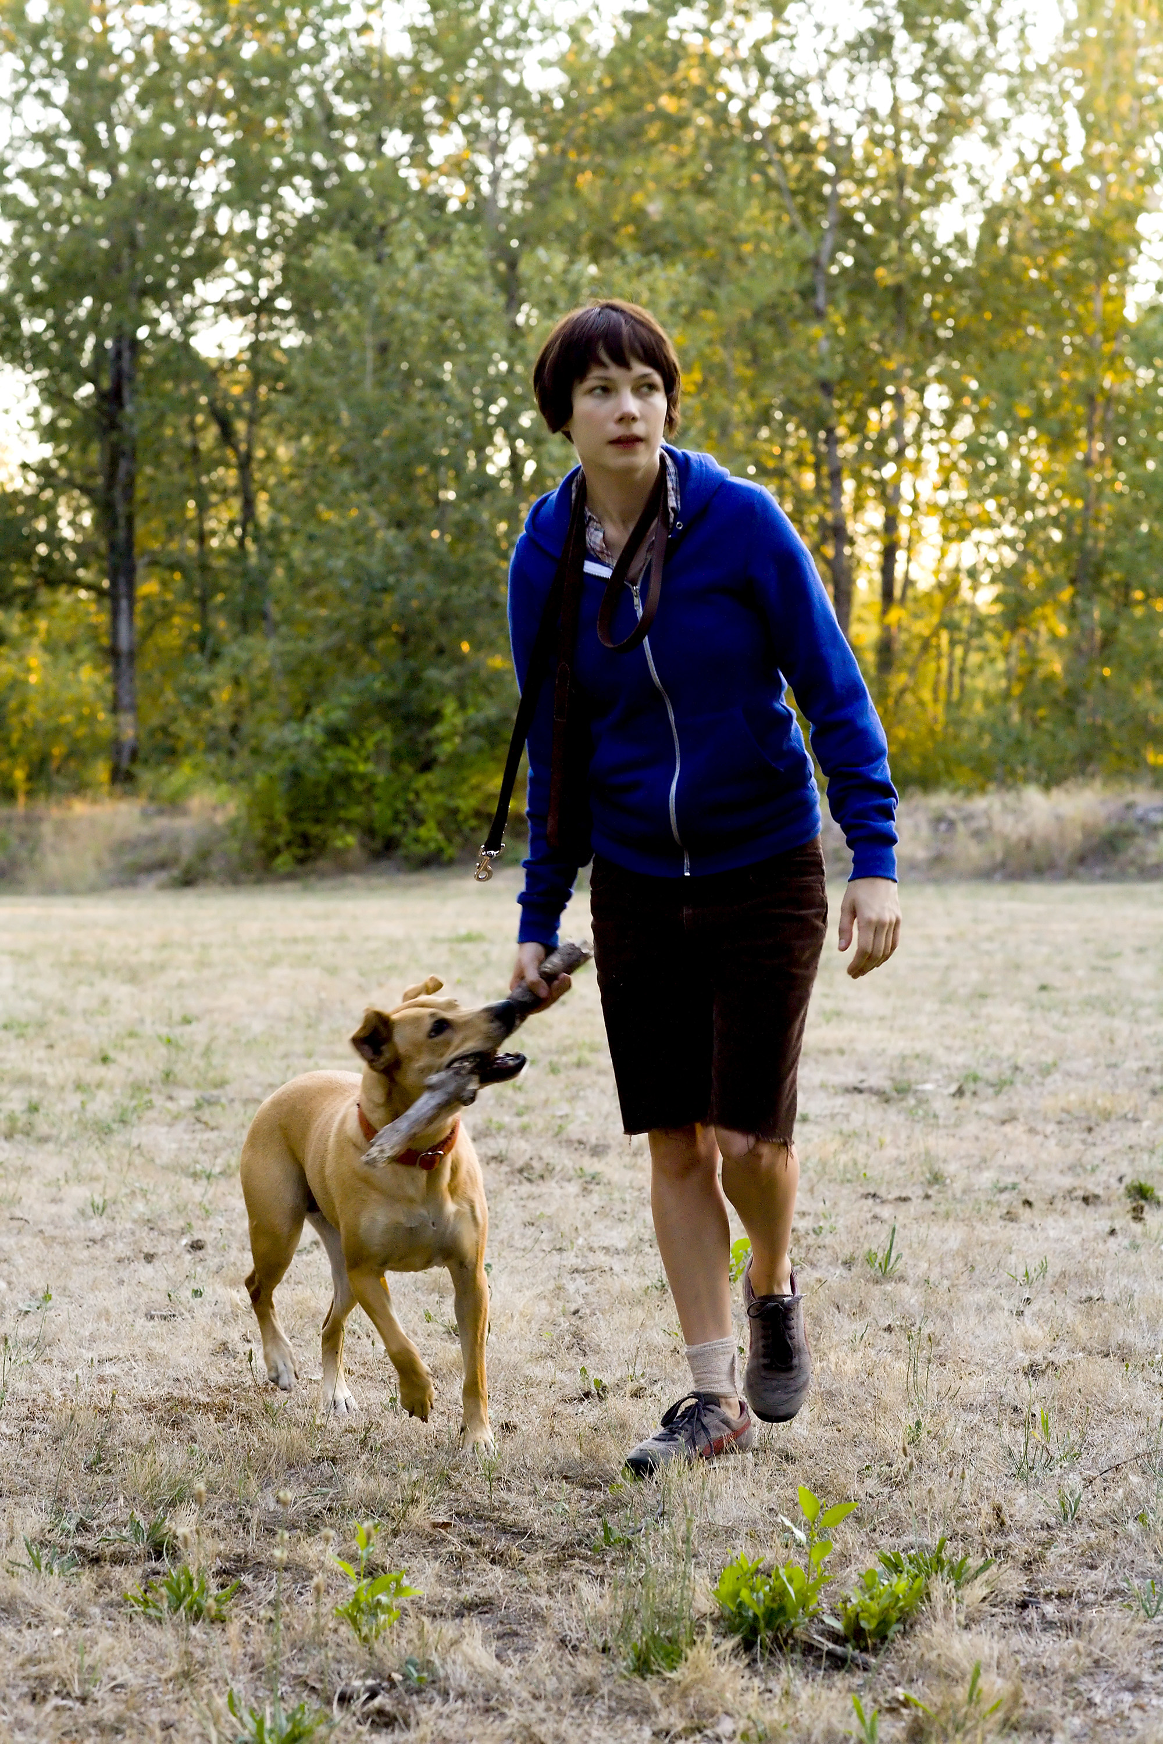
PRESS QUOTES

“Kelly Reichardt’s superb Wendy and Lucy, also in the running for the UCR prize, boasts no toddlers but an astounding Michelle Williams (in her best performance yet) and a canine who hits her marks even more than she did in Old Joy. Reichardt’s film won no awards at Cannes, but hopefully it will pick up something even more significant: U.S. distribution.”
Time Out New York, Melissa Andersen
“Continuing Old Joy’s promise of a new kind of American cinema, Kelly Reichardt’s Un Certain Regard entry finds its title characters—a young woman (a haunting Michelle Williams) and her dog—living off the grid. A deeply touching film about connection, abandonment and the struggle to maintain dignity, it miraculously avoids bathos while making quiet, forceful statements about poverty.”
Time Out New York, Melissa Andersen

“Kelly Reichardt […] has become one of the most interesting young American filmmakers.”
New York Times, Manohla Dargis and A. O. Scott

"Reichardt is no pessimist and her compassion for Wendy and belief in the kindness of strangers make for an optimistic film which should serve to build her already strong US reputation on an international scale, […] Williams is superb here, unbeautified and effortlessly natural as a woman driving a clapped out Honda from her homestate of Indiana to Alaska in search of lucrative work at a fish cannery."
Screen Daily, Mike Goodridge

Director Kelly Reichardt speaks softly. Her actress, Michelle Williams (from Brokeback Mountain) is the the very model of sobriety. Her composure renders even more piercing the brutality of Wendy’s devastating exclusion: her absolute solitude, prompted only by her poverty. Among the pessimistic films of this Festival, which were not in short supply, this is, without a doubt, the most beautiful and the saddest.
Le Monde, Thomas Sotinel

With Old Joy Kelly Reichardt revealed a strong, clean cut and refined storytelling style, thereby becoming a key figure of independent American cinema. […] Her devastating Wendy and Lucy confirms the coherence of her commitment to an uncompromising cinematic protocol, which is viscerally political and humane. Les Inrockuptibles

Wendy and Lucy is a small miracle of filmmaking. Mk2 Magazine « 3 Couleurs » (Blog)

"I've seen films about genocide at this year's festival, I've seen films about corruption, about terrible crimes, about war and about murder, but nothing cut me to the quick like Wendy and Lucy, which is about a girl who loses her dog. […] Reichardt has "created something of incredible emotional genuineness that's one of my favorites in the festival."
The Independent Eye – IFC Blog, Alison Willmore

"Because the film focuses entirely on Wendy and her relationship with her dog, Williams has to carry the film entirely, and she does so remarkably"
Cinematical, Kim Voynar

"Wendy's self-sufficient routine has a introverted, bitter stability, but her deep reliance on Lucy as the sole discernible human, emotional, tender existence in her life predictably, but movingly brings Wendy to a frazzled crisis.“
"Will Oldham's childish, nostalgic, and lyrical hummed theme for Wendy and her dog neatly encapsulates the film, which attacks a simple, sad theme with an exemplary, but modest cast and crew, who bring a powerfully sympathetic approach. The sadness is natural, and therefore all the more sad, and it takes a patience, a kindness, and a calm to bring an inner life, however painful, to such a film."
Auteurs' Notebook, Daniel Kasman

The New York Times – May 24th



A Cantankerous Crowd in No Mood for Love
By MANOHLA DARGIS and A. O. SCOTT
“[…] Although she probably would have won audiences over anyway, the American director Kelly Reichardt (“Old Joy”) was more favorably placed on Thursday evening with “Wendy and Lucy,” which showed in the more hospitable context of Un Certain Regard, a category for younger filmmakers. In the space of a few years, Ms. Reichardt — who offered a few shy words of hello before the screening, flanked by a cluster of male colleagues and her lovely star, Michelle Williams — has become one of the most interesting young American filmmakers.
Her latest follows Wendy (Ms. Williams), a girlish woman with watchful eyes and a hesitant smile, who, with her mutt, Lucy, is on her way to a new life in Alaska with too little money when she runs into trouble in Oregon. With uninflected realism, an attentive camera and no weeping strings, Ms. Reichardt makes palpably, tragically real what it means to be struggling at the very edge of the economic abyss.
Like “Old Joy,” which tracks two friends on a short trip to the country, “Wendy and Lucy” is political to the bone but without any of the usual grandstanding. As of Thursday night’s screening, though distributors were circling the room, this pitch-perfect triumph had yet to attract an American buyer. It will. “
Variety – June 2nd

Wendy and Lucy
"Old Joy" helmer Kelly Reichardt plays to her strengths in "Wendy and Lucy," a modest yet deeply felt road movie about an idealistic young drifter.
"Old Joy" helmer Kelly Reichardt plays to her strengths in "Wendy and Lucy," a modest yet deeply felt road movie about an idealistic young drifter, her faithful canine and the wide-open spaces of the Pacific Northwest. Once again working from a short story by "Old Joy" scribe Jon Raymond, Reichardt has fashioned another carefully observed, old-school indie portrait of regional American life that feels, in the best sense, as though it could have been made 25 years ago. Strong reviews and the superb central performance of Michelle Williams should help the film reach Reichardt's largest audience to date.
Living out of her car with barely two spare dimes to rub together, Indiana native Wendy (Williams) has, like the protagonist of last year's "Into the Wild," set out for Alaska, where she hopes to find gainful employment in a Ketchikan fish cannery. Things go awry, however, when her wreck of a car breaks down in Oregon and Wendy takes an ill-conceived stab at shoplifting dog food for her lone traveling companion, Lucy, whom attentive viewers will recognize as the same tan-colored retriever that accompanied the two male leads of "Old Joy" on their trek into the woods. (The dog is, in real life, Reichardt's own.)
Caught red-handed by an overly officious stock boy (well-played by "Elephant" star John Robinson), Wendy is arrested and slapped with a stiff fine. By the time she returns to the supermarket parking lot where she left Lucy tied up, the dog has disappeared.
Remainder of "Wendy and Lucy" concerns Wendy's efforts to fix her car and find her lost pet, which Reichardt dramatizes in a series of two-handers between Wendy and the various strangers, some kinder than others, who cross her path. They run the gamut, from the avuncular rent-a-cop (folk musician Walter Dalton) who lends Wendy the use of his cell phone, the straight-shooting auto mechanic (a delightfully eccentric Will Patton) with a jones for horse racing, and the vagrant (played by horror auteur Larry Fessenden, also one of pic's producers) who gives Wendy a deserved fright during a night she spends sleeping in a park. Collectively, they form a convincing panorama of the types one might encounter on such a journey, and it's a testament to Reichardt's skill with actors that even the smallest bit players give off the same lived-in, workaday feel.
Best of all is Williams, who doesn't say very much (no one in the film does), but who conveys an inexorable sense of longing for something more than life has given her. As with the rudderless, about-to-be-evicted Kurt character in "Old Joy," there is a sense that Wendy may be searching for a bygone, non-corporatized, "real" America that exists in ever-shorter supply, if at all. Also deserving mention is Lucy herself, who has few equals in the world of canine thesping, and was deservedly awarded Cannes' unofficial Palme Dog prize (from a jury that included film critics Derek Malcolm and Peter Bradshaw) for her performance.
Reichardt paints on such a miniature canvas that it seems as though, at any moment, the whole delicate house of cards could come undone -- if the pic were, for example, 81 minutes instead of 80. But like any seasoned traveler, Reichardt doesn't overstay her welcome and knows exactly when it's time to get back on the highway, building, as in "Old Joy," to a memorable ending suffused equally with possibility and melancholy.
Shot in mostly natural light by cinematographer Sam Levy, pic finds a faded but resonant beauty in gas-station restrooms, roadside phone booths and abandoned lots. Hovering above it all is the lyrical, ever-present gloom of the Oregon sky.
SCREEN – May 23th

Wendy And Lucy
Mike Goodridge in Cannes
Kelly Reichardt's third film is another small story revolving around seemingly banal events which, like its predecessor Old Joy, builds into a moving cry of despair for its alienated lead character, a young twentysomething woman called Wendy. But Reichardt is no pessimist and her compassion for Wendy and belief in the kindness of strangers make for an optimistic film which should serve to build her already strong US reputation on an international scale.
Also serving to boost the film's commercial appeal is Michelle Williams in the lead role. Although by no means a bankable star on her own, Williams is developing a sterling reputation as one of the most adventurous and versatile actors of her generation and this film, combined with upcoming titles from Charlie Kaufman, Lukas Moodysson and Martin Scorsese should continue to cement her name in both financing and critical circles.
Williams is superb here, unbeautified and effortlessly natural as a woman driving a clapped out Honda from her homestate of Indiana to Alaska in search of lucrative work at a fish cannery. Whether they are dead or estranged, she has no parents to lean on and one disinterested sister; in fact the primary relationship in her life is with her golden yellow dog Lucy.
Her schedule and money are tightly controlled so it's a blow when her car fails to start one morning in a small Oregon town. While waiting for the repair shop to open, she goes to the local supermarket for some dog food, leaving Lucy tied up on a leash outside. But, rationing her cash, she opts to shoplift the cans of food, is caught by an overzealous employee (Robinson) and dispatched to the local police station.
Although anxious to get back to Lucy, who is still waiting for her outside the supermarket, Wendy is detained for several hours and, having paid her $50 fine, returns by bus to the store only to find Lucy gone. Seized by mounting panic, she searches for the dog to no avail and has to wait until the following morning to reach the local dog pound.
In her quest for the dog, she is helped by a kindly parking attendant (Dalton) who lets her use his cellphone as the contact number on fliers which she posts in the neighbourhood. Meanwhile a mechanic (Patton) gives her bad news on the state of her car.
Reichardt's films are quiet and detailed, and in Wendy And Lucy , she provides an all too believable picture of how fine is the line between getting by and becoming homeless and destitute. Isolated from family and other support networks, Wendy even realizes that she cannot afford to look after her beloved Lucy.
Unlike Old Joy, which was a two-hander, Wendy And Lucy is told entirely from the point of view of one character - and her dog, of course. The beauty of the film is not only in telling a story with so few words but in showing the wordless tenderness that exists between woman and dog in a society which has cast her onto its fringes. Indeed, Wendy's forced layover in Oregon brings her into contact with some of society's undesirables. In the opening scene she tries to extract Lucy from the hands of a bunch of druggie wanderers and later on she is woken up by an unhinged homeless man in the woods where she is sleeping. Her flight of terror from this man, who doesn't hurt her, but might have done, is one of the film's darkest moments.

Boston herald.com – May 23th


Cannes’ final sprint
[...] Kelly Reichardt’s “Wendy and Lucy” continues this American independent filmmaker’s concerns with American lives on the margins. Wendy, played with reserve and enormous subtlety by Michelle Williams with a dark pixie haircut, finds herself stuck in a small Oregon town with her dog Lucy while on the road to a new life in Alaska. Her Honda Accord has broken down, she’s busted for shoplifting and while she’s processed at the jail, Lucy disappears. Reichardt, whose “Old Joy” two years ago was another gem, never condescends to any of her characters, whether they be a retiree working as parking lot police, a dog pound receptionist or the guy in the wheelchair who is bringing a bag of returnables to the grocery store to start his day. What’s even better in this season of movies that sometimes feel like endurance contests is that “Wendy and Lucy” runs around 80 minutes.
The Independent Eye (IFC Blog) – May 24th


Cannes 08: "Wendy and Lucy."

Saturday, May 24, 2008 | Alison Willmore
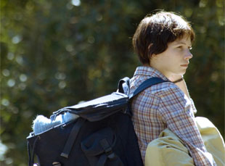
I've seen films about genocide at this year's festival, I've seen films about corruption, about terrible crimes, about war and about murder, but nothing cut me to the quick like "Wendy and Lucy," which is about a girl who loses her dog. The third film from Kelly Reichardt, whose superb "Old Joy" was one of the few bright lights on the American indie landscape of the past years, is, like that last feature, deceptively simple and brief. Over the course of 80 minutes, Wendy (a very good Michelle Williams) drives into a shabby Oregon town with her dog, Lucy. Every penny is s precious, so she tries to shoplift some dog food, but she's caught, and, per the store's policy and the insistence of an over-zealous young employee, prosecuted. Getting back a few hours later, she finds that Lucy's missing.
"Wendy and Lucy" is a microscopic tale of suspense about how, when you've got next to nothing, seemingly navigable setbacks like a car breaking down or a dog running away become insurmountable catastrophes. When Wendy runs into genial, hippie-ish vagrants by the railroad, one of them "Old Joy"'s Will Oldham, their stories make her decision to head to Alaska to look for work seems like a good one, like freedom. But she stranded in town when her car won't start, and while it's in the shop she has no place to sleep, and she has no phone number to give the pound should Lucy turn up, and without an address she can't get even a temporary job to sustain herself, which seems an impossibility in the economically depressed area anyway. The people around Wendy are mostly indifferent to her perilous descent into homelessness, with the exception of a security guard at the Walgreen's by which she's been staying, whose small acts of kindness and concern are heartrending.
Michelle Williams is in every scene of "Wendy and Lucy," and ably carries that burden — with her dark pixie haircut and cut-offs, she looks frighteningly vulnerable, an indie urchin stuck in circumstances both dire and mundane, her open face registering every frustration, triumph and terror despite her efforts otherwise. Reichardt's approach in the film is similar underplayed — by refusing to wring out easy sentiments from the script, which, like "Old Joy," is co-written and based on a short story by Jonathan Raymond; her actors; or her style, which is elegant and unobtrusive, the only music Wendy's own humming, she's created something of incredible emotional genuineness that's one of my favorites in the festival.
Village Voice – May 20th

Some Alternate Cannes Awards
Che wins the only Cannes award that really matters: ours

by J. Hoberman

An Endless Red Carpet for the Most Heroic Star Performance in Art or Life to Angelina Jolie for Changeling
Last year at Cannes, Jolie lost her husband to Islamic terrorists; this year, suggesting a skull costumed for Halloween in a cloche hat and kissable wax red lips, she’s no less distracting as the suffering single mother in another true story. The main attraction in Eastwood’s two-fisted gothic snake-pit weepie, Jolie loses her child to knaves, psychos, and the entire state institutional apparatus. (Michelle Williams’s understated performance in Kelly Reichardt’s modest—but cosmic—Wendy and Lucy gave a far greater meaning to the loss of a dog.) Meanwhile, La Jolie put herself in contention for a future chevaliership making multiple tapis rouge appearances in an advanced state of pregnancy and confiding in the press that she would be delighted to have her child born in France.
PEOPLE – May 22th

Michelle Williams Dazzles at Cannes Film Festival
By Brenda Rodriguez
Originally posted Thursday May 22, 2008 08:45 PM EDT

Photo by: ANNE-CHRISTINE POUJOULAT / AFP / Getty
Michelle Williams made a dramatic, last-minute appearance at the Cannes Film Festival on Thursday, walking her first red carpet since Heath Ledger's death to promote her film Wendy and Lucy.
"It was decided on Monday night that she could come to Cannes, and she got on the next plane to arrive just in time to get dressed and come to our premiere," said a rep for Wendy and Lucy. "She came in and had a long nap and then came to the screening."
Williams, 27, was radiant in a vintage Chanel Haute Couture dress. She will remain in Cannes at least through Friday night to promote another festival movie in which she appears, Synecdoche, New York, before flying back to the United States to resume filming a Martin Scorsese movie in Boston.
Williams has kept a low profile since Ledger died last January at age 28 of an accidental overdose. After attending his memorial service in Australia, she has spent time with their 2-year-old daughter Matilda in New York and on the set of her new film.
At Cannes, Williams's work in Wendy and Lucy was well-received, the rep says.
"Some people said tonight it was a transcendent performance," he says. "It's about things going on around her and she's just she's trying to go forward and things are not working out for her. You see her taking care of herself first [in the film], which is exactly what we must do."

CINEMATICAL (Website) – May 26th

Cannes Review: Wendy and Lucy
by Kim Voynar
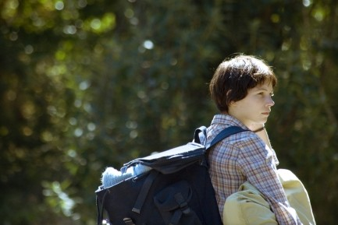
Director Kelly Reichardt's much-anticipated follow-up to her critically acclaimed 2006 fest circuit hit, Old Joy, continues to show Reichardt's remarkable gift for classically simple, deeply engaging storytelling. Wendy and Lucy is the story of Wendy (Michelle Williams), a down-on-her-luck girl who's hoping to turn things around for herself with a summer job at a fishing cannery in Alaska.
Wendy's making the trek from Indiana to Alaska in her beat-up Honda, accompanied only by her dog, Lucy, and about $600 to make the entire trip. When her car breaks down in a small Oregon town, Wendy is forced to make a series of increasingly difficult choices, and to rely upon the kindness (or not) of strangers to resolve her plight.
Wendy loses Lucy in this small, insular town at a time when she most needs the comfort of her canine companion to pull her through. Her agony in losing her only friend in this time of personal crisis is palpable; when Wendy endlessly walks the streets calling for Lucy, her increasing desperation rings through in the tiny wavering of her voice on the edge of emotional breakdown. The kindness of an aged security guard becomes the sole tether that keeps Wendy from losing it completely; Wendy's relationship with the guard shows how the kindness of a single stranger to a person in need can make the difference between holding it together or falling apart.
Where Old Joy relied on the subtle portrayal of a friendship and the emotional history of the two main characters, in Wendy and Lucy her focus is on this one girl who's in a bad situation; regardless of whether her own bad choices have put her there, we can't help but feel for Wendy and hope that she'll be alright. Because the film focuses entirely on Wendy and her relationship with her dog, Williams has to carry the film entirely, and she does so remarkably.
Reichardt's script is small and emotionally intimate. Where she could have chosen to beat her audience about the head and shoulders with endless exposition explaining how Wendy came to be at this point her life, she astutely chooses instead to focus on these brief moments in Wendy's life without judging, or expecting us to judge, the whys and wherefores of how she got there. Reichardt frames the shots perfectly, drawing us into Wendy's story visually rather than with lots of talky, stage-play dialog.
There are a couple of shots in the film that particularly speak to Reichardt's strengths as a filmmaker. In one scene, Wendy walks down the line of cages at the animal shelter, desperately hoping Lucy will be there. Reichardt pans the scene in one long, slow-moving shot, revealing the cages one by one as Wendy is seeing them, and pulling us into the weight of Wendy's desperate hope that she'll be reunited with her friend.
In one of the film's best scenes, Wendy, sleeping in the woods, alone and vulnerable for the first time without her friend and protector, is confronted by a half-crazed homeless guy who stumbles upon her as she's sleeping. She wakes, hearing the man searching through her belongings; he talks to her as she lies there, trembling in fear, only one tiny squeak of terror escaping her. Reichardt shoots this scene in tight close-ups, her lens focused mostly on Williams, who conveys all the emotional tension of this moment through the most minute of facial expressions.
Later, locked in the public restroom of a gas station, Wendy breaks down, ragged sobs escaping her as she struggles to pull herself together. The release of wrenching emotional tension in this scene fills the audience as well; Williams' fear and the weight of her desperation feel very real.
That Williams carries the entire film through moments like this is a testament to her under-appreciated abilities as an actress. She's grown tremendously over the past few years, and with two films at Cannes this year (she's also got a major role in Charlie Kaufman's Synecdoche, NY), she may be finally moving into a new realm in her career.
Fans of Old Joy will find much to like in Wendy and Lucy; after seeing these two films from Reichardt, I can't wait to see what she does next. Reichardt is a rarity, even among independent filmmakers; she excels at capturing these small, very human moments in the overall stories of her character's lives, bringing them to life with a restraint and beauty that many an A-list director could learn from.

Live from Cannes: Michelle Williams Shines at 'Wendy and Lucy' Screening
by Kim Voynar May 22nd 2008 // 8:32PM

I'll have a full review up of Kelly Reichardt's new film, Wendy and Lucy, up later, but a quick note on tonight's screening of the film. Reichardt made 2006's critically acclaimed Old Joy, and Wendy and Lucy was one of the films I was most looking forward to checking out here at Cannes.
The big movies are great, but the joy of seeing a smaller film like this at a fest like Cannes is one of the best parts of attending this festival. All I'll say for now is that I liked Wendy and Lucy even better than Old Joy, and Michelle Williams's performance (which is pretty much the entire film) is great.
Williams, looking absolutely lovely in a lacy gold dress, showed up briefly in the Salle Debussy theater with the cast and crew to wave at the crowd from the stage. Audience response to the film was positive, though I didn't really expect any boos with that much of the cast, and particularly Williams herself, in attendance.
I don't believe she stayed for the screening, though -- the pic above was taken on the red carpet for the premiere of Adoration, which was screening tonight next door at the Lumiere (with Cinematical's James Rocchi covering the red carpet for IFC), so I expect she quietly slipped out when the lights went down to attend that.
Upcoming: Review of Atom Egoyan's Adoration; tomorrow is the screening of Charlie Kaufman's Synecdoche, NY, and the Sony Pictures Classic lunch/roundtable for Adoration, followed by Wim Wenders's The Palermo Shooting

THE AUTEURS CINEMA – NOTEBOOK May 27th

Cannes Film Festival, 2008: “Wendy and Lucy” (Reichardt, USA)

Daniel Kasman
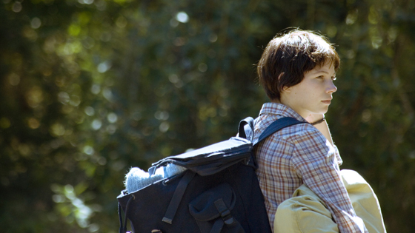
Above: Michelle Williams as Wendy.
Remember the utter destitution of Old Joy’s final scene, Will Oldham ejected from a deep, but expired and uncomfortable friendship into the unforgiving city streets of Portland at night? Such complete forlornness, hinting at a kind of utterly lost homelessness at the far end of a life prematurely derailed, is picked up again in a different way by director Kelly Reichardt in Wendy and Lucy. The two girls of the title are Wendy (Michelle Williams) and her dog Lucy, living out of a car and headed to Alaska for unclear visions of better times. Sullen, lonely, and pragmatic, Wendy gives little explanation beyond poverty and an impoverished family for her trek. When she is waylaid in a small Oregon town, the reason for her trip is quickly subsumed by a test to her solitary fortitude, debilitating isolation, and inner peace when first her car breaks down and then Lucy goes missing.
Giving quiet, but pointed consideration to a kind of economic anguish and wistful unhappiness of American suburban life, Wendy and Lucy’s full attention is devoted to a range of resolutely small town citizens, ranging from the warm and kindly, somewhat distanced concern of a parking lot guard (Wally Dalton), to a kind of post-hippie rudeness of a mechanic, and the more mysterious and cryptically eccentric range of equally lost young adults, inhabiting the Oregon woods and night talking of far off job possibilities (Wendy, like a Depression heroine, speaking of Alaska instead of California: “I hear they need people there.”) and the pain and anger caused by social rejection and invisibility.
These persons are all reflect Wendy’s turmoil, echoing it, prompting it, or showing darker paths in an unknown future, but they are on the sidelines of the film, which sticks with patient and profound sympathy to Michelle William’s incredible performance as Wendy. Wendy’s self-sufficient routine has a introverted, bitter stability, but her deep reliance on Lucy as the sole discernible human, emotional, tender existence in her life predictably, but movingly brings Wendy to a frazzled crisis. Suddenly her limited, but workable world of poverty and isolation falls down and she finds herself open to the harshness of a world as unhappy as she is, but for the most part far less vulnerable. Will Oldham’s childish, nostalgic, and lyrical hummed theme for Wendy and her dog neatly encapsulates the film, which attacks a simple, sad theme with an exemplary, but modest cast and crew, who bring a powerfully sympathetic approach. The sadness is natural, and therefore all the more sad, and it takes a patience, a kindness, and a calm to bring an inner life, however painful, to such a film.
Le Monde – May 26th


SÉLECTION OFFICIELLE - UN CERTAIN REGARD
Propositions éclectiques et provocantes

Jean-Luc Douin et Thomas Sotinel

n certain regard : le nom de cette section parallèle à la compétition (et néanmoins composante de la sélection officielle) induit que les films qui y figurent proposent une réflexion sur l'art et la manière de filmer, un point de vue personnel, décalé, sur le monde. Du film de Steve McQueen, Hunger, qui a ouvert cette section et remporté la Caméra d'or, au dernier long métrage projeté, Wendy and Lucy, de l'Américaine Kelly Reichardt, la plupart des films proposés n'ont pas dérogé à cette exigence.
[…]
BRUTALITÉ DE L'EXCLUSION
C'est plus par son objet que par sa manière que Wolke 9, de l'Allemand Andreas Dresen, surprend. Une femme quitte son mari, qu'elle croyait aimer, parce qu'elle a rencontré un autre homme. Ce serait ordinaire, mais elle a 65 ans, ils en ont quinze de plus.
Tout le prix de ce film est dans la façon dont Dresen impose cette situation avec autorité et patience. Il montre des gens qui s'aiment et se le prouvent physiquement. Le spectacle est d'abord choquant, jusqu'au moment (qui survient assez vite) où les personnages, leur plaisir et leur souffrance, l'emportent sur l'usure des corps.
Wendy and Lucy raconte une toute petite histoire : une jeune femme traverse une ville de l'Oregon. Elle est partie d'Indiana pour l'Alaska, dans l'espoir de trouver du travail. Elle a une voiture, 500 dollars en poche. Et puis Wendy perd Lucy sa chienne, et tout se défait.
Kelly Reichardt, la réalisatrice, filme d'une voix douce. Son interprète, Michelle Williams (vue dans Le Secret de Brokeback Mountain) est d'une exemplaire sobriété. Cette retenue rend encore plus aiguë la brutalité de l'exclusion qui s'abat sur Wendy, sa solitude absolue, qui ne tient qu'à sa pauvreté. Parmi les films pessimistes d'un Festival qui n'en a pas manqué, c'est sans doute l'un des plus beaux, des plus tristes.

Les Inrockuptibles – May 27th


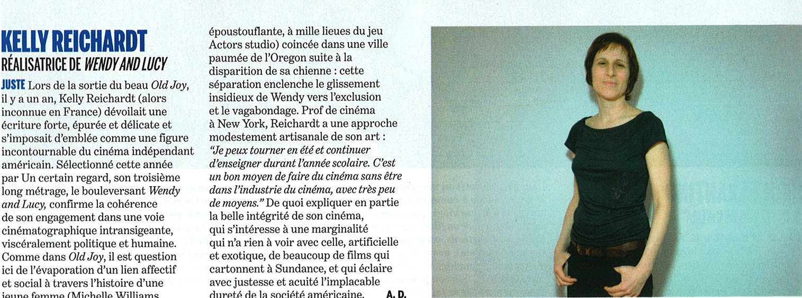
MK2 Magazine « 3 Couleurs » (Blog) – May 25th


WENDY AND LUCY
Sandrine Marques
Kelly Reichardt nous avait bouleversés avec Old Joy. Elle réitère sa performance avec son dernier film, de nouveau produit par Todd Haynes. La réalisatrice met en scène un duo, formé par Wendy (Michelle Williams, magnifique) et Lucy, sa chienne. L’animal appartient à la réalisatrice et occupait déjà un rôle important dans Old Joy. L’argument est minimaliste : Wendy fait la route avec son chien, direction l’Alaska. Sa voiture, dans laquelle elle dort, la lâche à Portland. Pour nourrir son chien, Wendy vole de la nourriture et se retrouve fichée. Elle accumule d’autres revers de fortune qui la conduisent à faire un choix douloureux. Kelly Reichardt, à sa manière sensible et intelligente, dresse le portrait d’une Amérique de laissés-pour-compte où chaque acte de sa bouleversante héroïne se transforme en geste de survie poignant. Wendy and Lucy est un petit miracle de cinéma.
Ecran Large .com – May 25th


« Au sein d'Un certain Regard, on retiendra le fabuleux esthétiquement parlant Hunger, un premier film violent et hypnotique (bien parti pour La caméra d'or ?) ; le trip libanais de Joana Hadjitomas et Khalil Joreige, Je veux voir qui insuffle de la beauté dans un pays sinistré ; Wendy and Lucy de Kelly Reichardt pour la performance remarquable de son actrice principale Michelle Williams. »
Film de Culte (Blog) – May 23th


WENDY AND LUCY – Un Certain Regard

Kelly Reichardt, célébrée par un joli buzz l'année dernière avec Old Joy, présente son nouveau film, toujours produit par Todd Haynes, dans la sélection Un Certain Regard. Wendy and Lucy suit le parcours caillouteux de Wendy (Michelle Williams) et de sa chienne (Lucy, donc), bloquées dans un trou de l'Oregon, point de départ des beaux lendemains promis en Alaska, la destination visée. Mais rien ne se passera comme prévu, et Reichardt, qui carbure à l'économie (petit sujet, petite durée, petite ambition), en dit pas mal en en montrant (ou démontrant) assez peu. Soit un moment de vie que l'on sent déjà effilochée, portrait d'une marginalité et de ses débrouilles précaires, de ses sacrifices aussi, d'une voix presque aphone car la détresse, chez Reichardt reste tragiquement muette, réfugiée dans un train sans qu'on ne sache vraiment si la destination rêvée vaut mieux que le point de départ. A noter que Lucy, toutou de la réalisatrice, a obtenu la très officielle Palm Dog, qui a, par le passé, récompensé le toutou de Persepolis et celui de Marie-Antoinette. Le film, lui, a reçu une belle ovation méritée.
Press and media coverage of Palm Dog 2008

http://entertainment.timesonline.co.uk/tol/arts_and_entertainment/film/cannes/article3962684.ece

http://www.telegraph.co.uk/news/newstopics/howaboutthat/1996088/Cannes-Film-Festival-canines-battle-it-out-for-top-Palm-Dog.html
http://www.telegraph.co.uk/news/newstopics/howaboutthat/1991017/Cannes-Film-Festival-Palm-Dog,-theprize-for-the-top-dog.html

http://uk.movies.ign.com/articles/876/876561p1.html?RSSwhen2008-05-25_121100&RSSid=876561

http://www.independent.co.uk/opinion/leading-articles/leading-article-doom-and-gloom-in-cannes-833600.html

http://www.petsugar.com/1656518

http://www.webuser.co.uk/news/news.php?id=256997

http://news.yahoo.com/s/afp/20080523/od_afp/entertainmentfilmfestivalcannesanimalsusoffbeat_080523151040

http://www.news.com.au/couriermail/story/0,23739,23750585-5012980,00.html

http://video.aol.com/video-detail/cannes-spotlight-palm-dog/664959004

http://buzzsugar.com/1657432

http://ca.news.yahoo.com/s/afp/080523/oddities/entertainment_film_festival_cannes_animals_us_offbeat

http://www.gulf-times.com/site/topics/article.asp?cu_no=2&item_no=220258&version=1&template_id=39&parent_id=21

http://movies.feedables.com/story/279429/Cannes-2008-Palm-Dog-News

http://www.webuser.co.uk/news/256997.html?aff=rss

http://rawstory.com/news/afp/US_mongrel_scoops_Palme_Dog_prize_a_05232008.html

http://www.findinternettv.com/Video,item,3700644641.aspx

http://www.thedaily.com.au/news/2008/may/24/aap-mutt-scoops-palme-dog-prize-at-cannes/

http://www.cupofdog.com/2008/05/24/best-in-show-cannes-edition-ii/

http://www.zijonline.nl/overviewrss.asp?rssID=Cannes%20Spotlight:%20Palm%20Dog&roddels=51100

http://www.france24.com/en/20080523-us-mongrel-scoops-palme-dog-prize-cannes-film-fest

http://news.lycos.co.uk/querkies/080523151040.31tgy1vm.xml.html

ttp://www.dogfoodcentral.com/

http://nymag.com/daily/fashion/

http://entertainment.news-video.org/2008/05/24/cannes-spotlight-palm-dog/

http://www.thepeninsulaqatar.com/Display_news.asp?section=World_News&subsection=Rest+of+the+World&month=May2008&file=World_News2008052471555.xml

http://www.mywire.com/pubs/AFP/2008/05/23/6469908

http://services.inquirer.net/print/print.php?article_id=20080523-138440

